NIM : 32230107
Nama : Steven Setiawan
- Movie Home
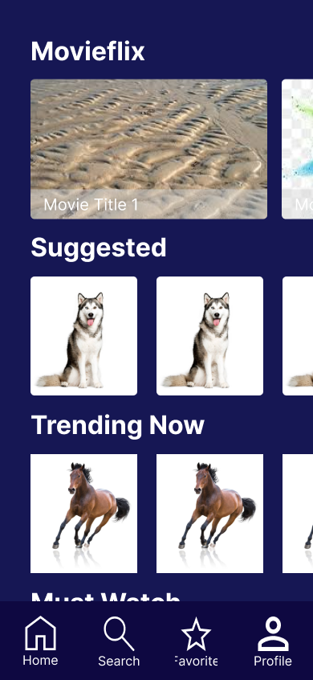

- Movie Detail
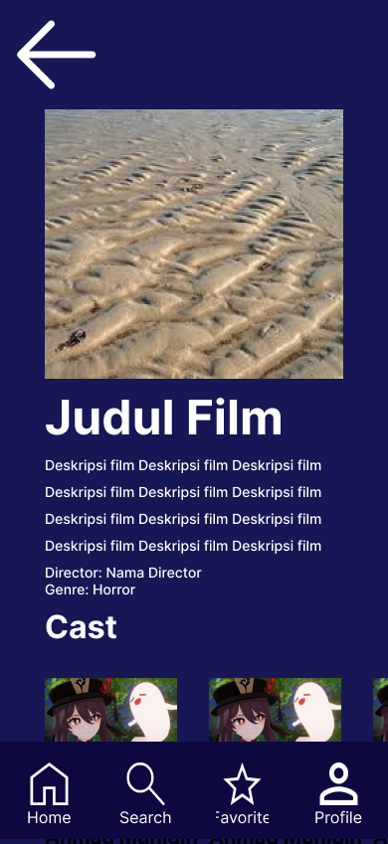

- Link Figma: https://www.figma.com/design/VWfLSZDtJC3HG84fQAv8oe/pert-10-ui-ux?node-id=0-1&t=GKeXENgaSG6Dhrqu-1

